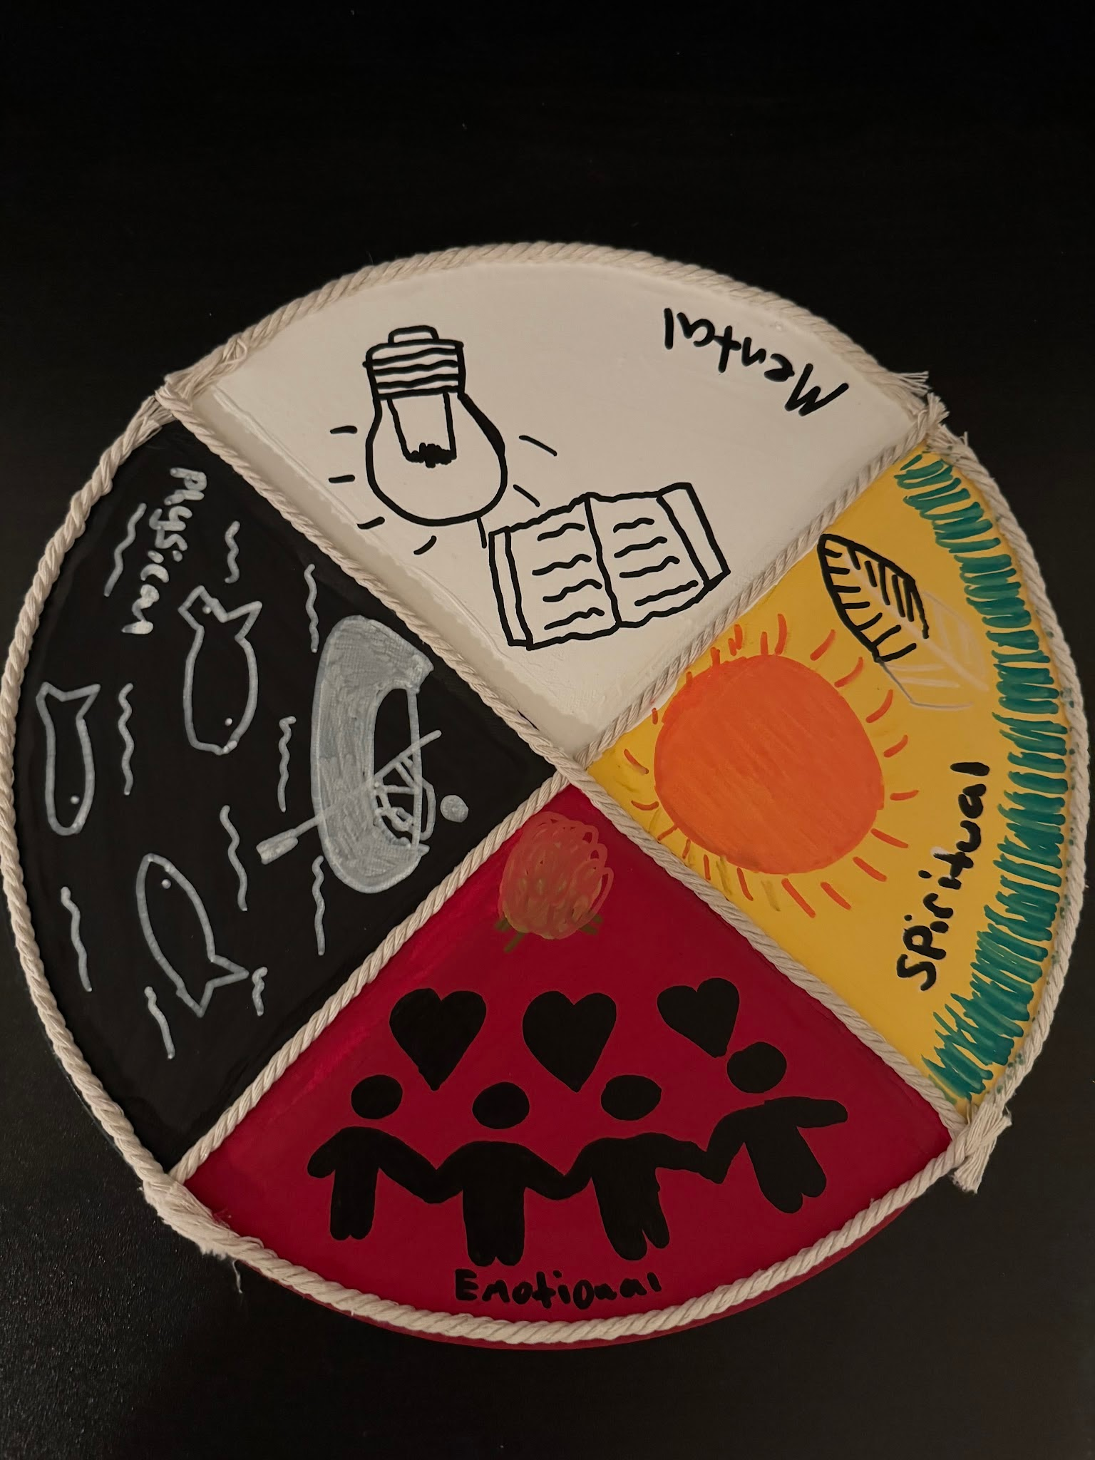

https://www.ictinc.ca/blog/what-is-an-indigenous-medicine-wheel

https://www.nlm.nih.gov/nativevoices/exhibition/healing-ways/medicine-ways/medicine-wheel.html

https://www.stjo.org/native-american-culture/native-american-beliefs/medicine-wheel/

When this project was first assigned I originally wanted to make a snowshoe, once I figured out how hard it would actually be I changed my mind pretty fast. The medicine wheel popped out at me since I already had some of an understanding of what it is. I made my piece using references I found online. I added a few of my own touches and put in some hard work. I wonder if the Indigenous peoples would approve. I would like to think they would.

